
DOC2453599-1

New World Industries Inc.

Set-up and Operation
PA-1 Program Adapter

Introduction
Thank you for purchasing PA-1. Unlike a expensive and cumbersome laptop, PA-1 is a small, conventional and portable device use to set your controller’s parameters. The PA-1 uses RS-232 serial communication protocol to communicate with your controller. It has a Liquid Crystal Display (LCD) screen, which let you visually set your controller parameters up to two decimal places. No software installation is required. PA-1 is a plug and play kind of device. See figure one for the inside content of PA-1.

Unpacking
The following items are included.
PA-1
Manual for PA-1
Ribbon cable

Note you will need 9V Battery, not included.

General Precautions
- Never immerse PA-1 in the water
- Do not puncture and apply pressure on the LCD screen
- Do not short out the programming/communication pin headers.
- Ribbon cable comes with polarized tab. It makes contact with the pin header in only one direction. Never force it in.
- Do not take the cover off the programming pin header. The programming pin header is for Factory use only.
- Turn the power off when not in use.

OPERATING INSTRUCTIONS

Power On
- Connect 9V battery to the battery strap and push it down the battery holder.
- Push down the on/off switch to turn PA-1 on and off. When PA-1 is on it will display a welcome text.

Communication Pin Headers
LCD Screen

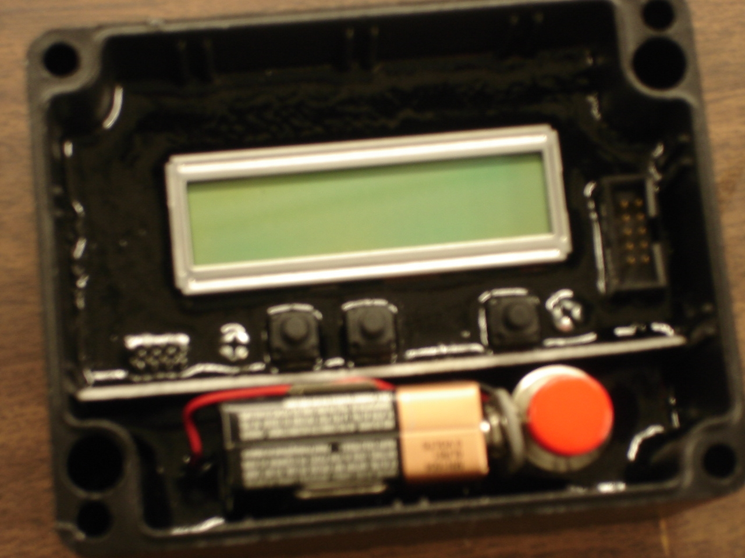
Programming Pin Headers
Left Shift Button
Right Shift Button
Enter Button
Battery
Figure 1. PA1 device. Top view
Power Button

Communicating to the controller
- Turn PA-1 power off.
- Communication pin headers are located to the right of LCD screen.
- Take the cap off and connect PA-1 to the controller using the appropriate cable.
- Turn PA1 power on. You will see the welcome text and PA-1 will prompt you to press the Enter key. The blinker should be blinking on the word ENTER. The left and right buttons move the blinker left and right respectively.
- When you are ready to begin communication between PA-1 and controller, move the cursor anywhere on the word ENTER and press enter button to.
- If communication is successful PA-1 will display what device it is connected.
- After a second, you will see the first controller parameter and its value on the top line and “Next Update Exit” on the second line. The blinker now blinks on the word Next.
- In order to scroll to the next parameter on the list, move the blinker on the word “Next” that is displayed on the LCD screen and press the Enter button.
- If you want to update that particular parameter shift the blinker to the right and. highlight any letter of Update. Then press the enter key to update the value.
    - You will see what you are updating on the top line. Its value and “- + Save” on the bottom line.
    - The blinker blinks on “-”. If you would like to increase the current value move the cursor over “+” and press the enter button. You will see the value increment by one. If you would like to decrease the value move the cursor to the left and highlight “-“ and press enter.
    - Once you have reached the desired value move the cursor anywhere on the word “SAVE” and press enter. This will write the new value on the controller and exit out of update task. Then the next parameter will appear on the screen.
    - If you want to go the next parameter move the blinker over anywhere on the word “NEXT” and press on the enter button. You will see whatever the next parameter is and its value on the screen. When you reach the end the parameter list PA-1 will scroll back to the first parameter on the list.

- After completing setting all desired parameter value on the controller, you can move the cursor over EXIT and press enter to exit.
- To conserve battery power, please turn the power off after setting up your controller.

Lighting
The LCD screen does not have backlight feature. You need sufficient ambient light in order to see what is being displayed on the screen.
Distance
The standard adapter cables are 3ft long.

Frequently Asked Questions

How do I reset PA-1?
Turn the power off and on again. This will reset PA1’s processor.

Why can’t I see the welcome text on the LCD screen when I turn the power on?
- PA-1 battery power might be low. Please replace the battery.
- Make sure the battery strap is locked to the battery’s positive and negative terminals and have a good contact.

Why does the text on the screen look soft?
The LCD contrast is preset at the factory to the maximum value. If the texts on the screen look soft your battery power is running out. Please replace the battery.

Nothing is happening when I press the enter button on Enter. Why is that?
- PA-1 is having some difficulty communicating with the device. Make sure the ribbon cable is securely plugged in to PA-1 and your controller. While the cable is still attached turn the power off and back on and try to establish communication again.
- If that does not solve the problem turn both PA-1 and controller power off wait for 5 sec and turn the power back on. Try to establish communication again.
Some of the controller’s parameter values seem odd. How can I get the correct value to display on the screen?
Reset PA-1 and try to communicate to the device again.

How do I modify my controller setting?
See operating instruction.
I have been using PA-1 for over a year. Now it does not work sometime. What am I doing wrong?
The cable might be worn out. Replace the cable with new one from SAMTEC. The part number is HCSD-05-D-24.00-01-N.
I have replaced the ribbon cable recently and I can’t communicate with my controller. Why is that?
Make sure the cable you have replaced has polarity tab. The part number is HCSD-05-D-24.00-01-N. You can purchase it from SAMTECH.

NEW WORLD INDUSTRIES INC., 220 CAPITIAL DR. N.E. SUITE 300 BUFFALO, MN. 55313/PHONE: 763 684-2027
COPYRIGHT, NEW WORLD INDUSTRIES INC.2005

